Contents

Introduction 1

Tenet #1: Keep Total Cost of Ownership Low 3

Tenet #2: Leverage the VA API Marketplace 6

API Portal: 7

API Exchange and Catalog: 7

API Gateway: 7

Consumer Types 7

API Change Management 7

Tenet # 3: Microservices Architecture 7

Tenet #4: API Solutions are fundamental to any VA IT initiative 11

Tenet #5: Architecture drives API Solutions 13

Tenet #6: Low Code Solutions: 15

Overview 16

Objective 16

Scope 17

Approach 19

Framework Risks 20

# Introduction

As part of VA’s shift to digital solutions, VA has made a commitment to leverage “API Solutions” as a fundamental approach to solving IT problems. To provide the strategic direction of the VA, it is required to define the key visionary aspects, hereby referred to as the VA API Tenants. Within this document, we define the most important principles of Integration and how they apply to VA context. Throughout the document, there will be references to the VA API tenants, as well as their supporting subcomponents, and how they’re impacted by VA’s people, process, and technology. Below are the brief definitions of people, process, and technology.

* People: The roles and responsibilities to build and maintain Integration Solutions.
* Process: Methodology and governance to build and maintain Integration Solutions
* Technology: Integration platforms and codified assets developed to connect

The API Developer Playbook currently is focused on “Technology” and the associated accelerating “Processes”. Future versions will include more standards around “People” and more “Process”.

Technology:

API Solutions can be comprised of different technologies, platforms, and IT components, ranging from API, queue, security, datastores, cloud platform, and other key components on the typical “Microservices Reference Architecture.” It is important to understand the supporting reference architecture, because API Solutions are rarely bundled into a single platform, as well as API solutions have supporting capability needs from other architecture components (for example: queuing, CICD, Caching, etc.) Instead, a collection of best-of-breed technology platforms are leveraged. Below is Visual Integrator’s Integrator’s Reference Architecture, which maps all the archicture capabilities into a Reference Architecture diagram, displaying the groupings, relationships, and the API and supporting integration technology responsibilities. Note, the diagram displays a complete Reference Architecture capturing all possible capabilities, some of which may be prioritized higher for VA teams. It is important to map which are most important to enable the VA to produce agency and business solutions.

Figure 1: Visual Integrator Reference Architecture



*Reference Architecture Diagram Copyright Visual Integrator Consulting, 2003 - Current*

VA is committed to building solutions on API’s to ensure a modern, loosely coupled, scalable, and flexible approach to building applications and data sharing.

Some of the key aspects of API’s include:

* Scalable
* Flexible & Changeable
* Adaptable
* Secure
* Well-Performing
* Modernizable
* Re-Usable
* Patterns
* Frameworks

To accomplish, the Developer Playbook has an overview of the key API tenants, so that developers understand the vision, purpose, and approach towards leveraging API based solutions.

The VA API tenants include:

1. Keep Total Cost of Ownership Low
2. Leverage the VA API Marketplace (Portal and Catalog)
3. Follow a Microservices Architecture
4. API Solutions are fundamental to any VA Solution
5. Archicture drives VA Solutions
6. Follow Low Code approaches

# Tenet #1: Keep Total Cost of Ownership Low

There are always multiple approaches to solving problems. In the IT landscape, this could be in the magnitude of 50 different potential approaches to solve a problem, especially when considering the number of solution platforms, programming languages, and vendors with similar or competitive offerings in the marketplace. Rationalizing the “best fit solution” to solving a problem can be challenging, if not downright cumbersome, when there are so many choices. Factoring in human factors such as strong opinions, level of comfort, curiosity, personal favoritism or biases, can make choosing a solution approach even more challenging. Ultimately, choosing a solution approach should be based on what is best for VA, when considering cost and overall benefit or value derived from the selected approach.

For API the goal is to build or re-use existing integration assets as an enabler for solutions across the entire VA Enterprise.

To accomplish this, the VA will follow approaches that invest in architecture and supporting frameworks that can be re-used across API Use Cases and solutions. Such frameworks and approaches are documented in this API Playbook, and of course require an upfront investment to reap the benefits downstream. As illustrated in the graphic, creating the API Playbook, which includes foundational architecture and enabling frameworks, allows for the VA to have the blueprints for building new functionality and leveraging re-usable assets, ultimately making the solutions operational and deriving value for the long haul.

Figure 2: Cost of Ownership Curve



At times, there may be a simpler, less complex implementation approach than the “standard API” approach, which seem faster or even less costly. However, alternatives from the standard must be justified to determine if they present long-term lower ownership costs. In other words, what may seem simpler on the surface, may be costlier over long haul. This especially holds true when measuring factors such as operations and sustainment, change management, future solution modernization, scalability, flexibility, and overall governance. The most common issue is building a point-to-point or 1-off solution that is costlier of the long haul to manage, maintain, and support—hence, a higher Total Cost of Ownership.

Figure 3: TCO through API based Solutions



To maintain low Total Cost of Ownership, the following principles shall apply:

* Leverage the standard API platforms, tools, and technologies, selected by VA and justify any exceptions to the standard for consideration
* Leverage the architecture patterns and approaches established by VA.
* Leverage the enabling “API Frameworks” established by VA.
* Bring collaboration and feedback on the standards to the Enterprise Services API Governance Council as early as possible so it is considered in the design and rationalization. If the scope is broader than VA ES, then the Enterprise Services API Governance Council shall consult with other VA groups and teams to establish the proper solution approach.
* Leveraging VA standardized “Cloud based platforms” to keep costs low. When considering cloud platforms, the preference is to leverage Platform as a Service (PaaS) as the first criteria (See Section on Tenet: Microservices Architecture). Second criterion is to leverage “container-based solutions” so the microservice can be created, deployed, and managed independently from other microservices, Operating Systems, or Virtual Machines. This will help keep the TCO low.

Below is a diagram illustration the considerations when rationalizing the cloud approach, and which cloud deployment architecture is appropriate (SaaS; PaaS; IaaS).

Figure 4: Cloud Rationalization Considerations



# Tenet #2: Leverage the VA API Marketplace

The concept of a marketplace is important to promote re-usability. It will allow API Consumers have a single place to “shop for API’s”: find, discover, browse, and ultimately consume (i.e. “buy”) usage of API’s.

Figure 5: API Marketplace and Exchange Concept



The Guiding principles of the VA API Marketplace includes:

## API Portal:

Providers and Consumers can interact through a common site. Consumers can onboard, test

## API Exchange and Catalog:

The API is discoverable, searchable, and easy to find for re-use.

## API Gateway:

The routing and brokering mechanism for all API invocations.

## Consumer Types

There are diverse types of Consumers of the API, such as System (On Premise, Cloud, SaaS); An Application (Mobile, Portal, Web UI); Trading Partner; Developer (Internal or External).

## API Change Management

Manage API versions, onboarding, off-boarding, deprecation multiple concurrent versions

Analytics:

Visibility into the API performance, statistics, and trends

# Tenet # 3: Microservices Architecture

“Microservices is a software architecture style in which complex applications are composed of small, independent processes communicating with each other using language-agnostic APIs. These services are small building blocks, highly decoupled and focused on doing a small task, facilitating a modular approach to system-building.” (Reference Wikipedia, <https://en.wikipedia.org/wiki/Microservices>)”

The diagram below illustrates the concept of building solutions by “mashing up” independently developed and managed API objects together, to build the foundation and logical componentry of the solution itself.

Figure 6: Microservices Architecture



The key principles of a Microservices architecture includes:

* Engineer APIs into individually deployable and manageable assets. Each API is engineered to be individually deployable as its own package, and not grouped together with other APIs into a package of APIs. A package has only 1 API. This allows the API to be an individual unit of work that can be governed, managed, version controlled, and tested at the lowest level of granularity. It provides flexibility to control the API for operations, sustainment, and re-usability.
* Create an API Catalog (i.e. a Repository) that is a catalyst for re-usability. By managing the microservices individually, they can be published into the API Catalog for API Consumers to discover them. All API Consumers should check the API Catalog for existing APIs for re-usability, before developing a new API. This helps keep the TCO low, as it results in fewer IT assets to manage. If an existing API is a “near fit,” but not an “exact fit,” the API Consumer should consider requesting the API Provider make a change to the existing API to create an updated version of the API that is an “exact fit,” instead of the API Consumer requesting a new API.
* Microservices architecture allows for fine grained APIs (i.e. Services) to be built and composed upon in a component building-block approach. For example, in the diagram below, the fine-grained services are built as the “Technical Services” that have a specific function encapsulated in each API. The “Business Services” make use of the “Technical Services” by consuming them, and thereby making them highly re-usable. The “Business Services” are consumable by VA Business Processes to orchestrate (i.e. process in a sequential workflow process) and manage the business process, thereby making the end-to-end business process and orchestration of Business Services enabled by APIs. This architecture and solution approach would not be possible without the Microservices Architecture and Service Composition to build solutions.

Figure 7: Service Composition through Microservices

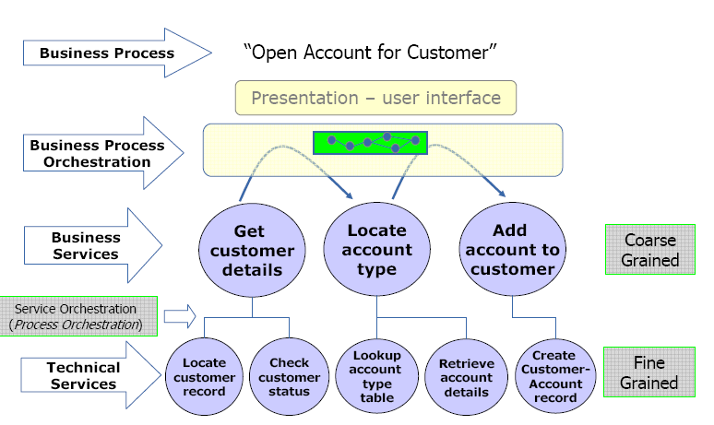

* The anti-pattern is to build IT assets into large chunks of componentry, such as big chunks of code, long running orchestrations, and APIs that are not separated. This type of architecture can be inflexible, difficult to maintain, challenging to test, prohibit re-usability or composability, and can be inefficient or deficient during runtime.

Figure 8: Anti-Pattern BLOB



Figure 9: Example of BLOB Anti-Pattern

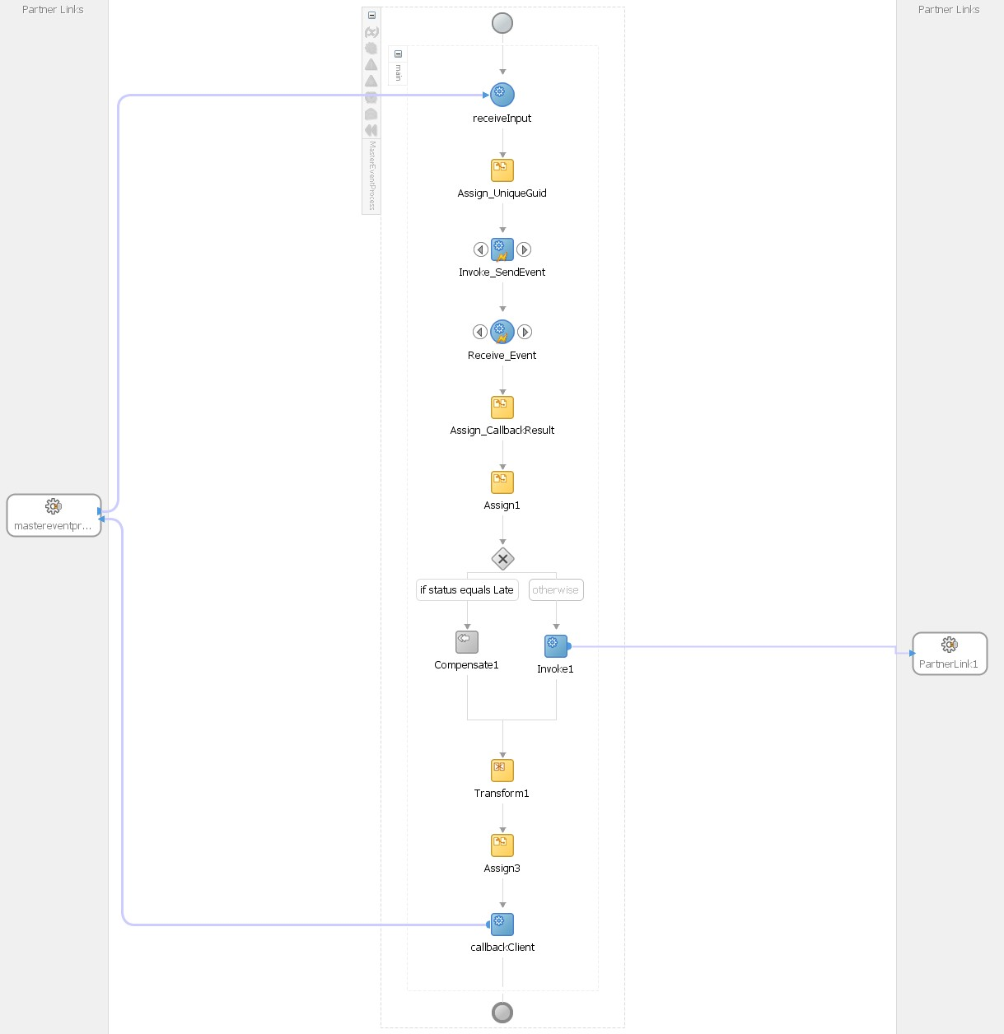

* New Applications, User Interfaces, and other User-centric solutions (i.e. Mobile, Portals, Extranets, Intranets) shall be a mash-up of APIs to create the solution. There shall not be integrations or middle-tier IT assets created directly from UI to data sources. Instead, the UI shall consume APIs that provide all the middle-tier logic and data.
* Design patterns shall leverage a 3-layer approach, like Model-View-Controller with the following responsibilities:

Figure 10: 3-Layer API Architecture

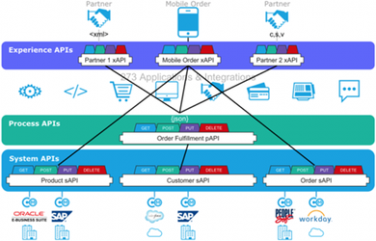

Experience: Consumption ready API for User Interface consumers and Trading Partner consumers.

Process: Transformations/Translations to and from Canonical; Business Rules; Orchestration of Business Process. The orchestrations may perform data aggregation (split-join), conditional routing (if Region=APAC then do this…), filtering (Only show available orders), and more.

System: The most granular layer that represents interaction with data sources/systems of record and consumer/destinations systems.

* The responsibility of each microservice is to perform a small unit of work, with a single responsibility. That entire responsibility shall be encapsulated in the API itself.
* APIs can support a plethora of data formats but predominantly JSON is preferred. Micro service is normally exposed as HTTP(s) service.

# Tenet #4: API Solutions are fundamental to any VA IT initiative

The paradigm shifts to allow API solutions as the foundation of any IT solution. Whether it’s a new application, mobile solution, a new data sharing service, an analytics platform, a new business process model (BPM) or workflow, such solutions should be built onto an API layer as the foundation. Without such, VA teams run the risk of building 1-off solutions, which quickly become unmaintainable, often referred to as spaghetti or hairball. Additionally, the solutions should leverage the blueprints and frameworks from this API Developer Playbook, so that there is a single approach to doing core technical approaches. For example, a common and re-usable approach to logging, error handling, authentication, and more.

Figure 11: Anti-Pattern of No Architecture

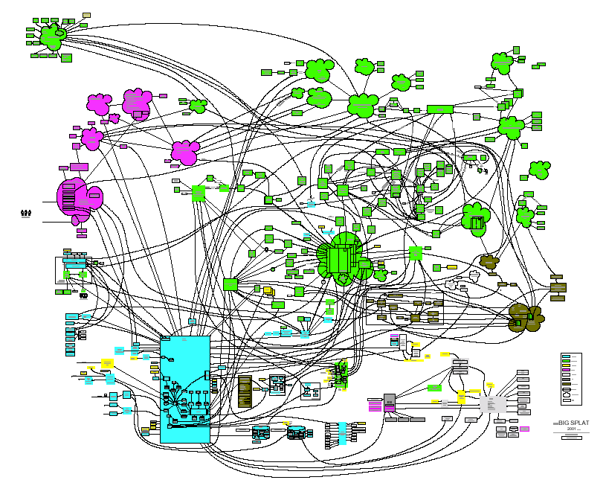

Some of the core principles to leveraging API solutions and architecture into all VA IT solutions includes:

* Any IT solution that is being built at VA should leverage API Solutions early in the project charter, and not at the end of the project initiative. Integration Solutions should be analyzed upfront, and the possibility of re-usability of existing Integration Solutions should be explored.
* Contract First Design approach: The API contract is developed before the API inner logic is developed. The contract is the skeleton or the shell of the API. By building the contract first, the API Consumer can leverage the API contract to build their consumption of the API, before the API is ready. This is helpful because in a microservices solution, the API consumer is dependent on the API to complete the business process. As represented in the diagram below, the API is modeled before the API is engineered. This way, the API can be simulated, and solicit feedback and validation with the consuming systems in parallel with the development team building the API.

Figure 12: API Contract First Design Illustration

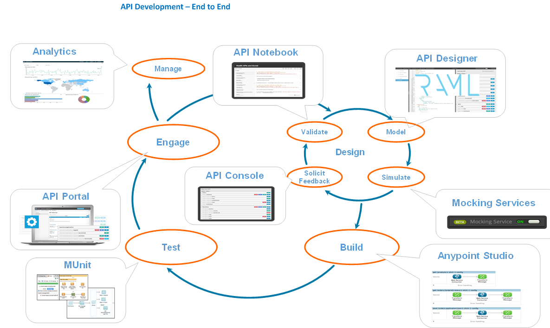

There are 2 standards for API contracts. 1) Swagger and 2) RAML.

A single RAML file can define more than one API but its recommended to group related APIs together into a single RAML file. For example, all product related APIs can be developed in single product. raml and all customer related APIs can be implemented in customer.raml

# Tenet #5: Architecture drives API Solutions

Architecting the API tends to much more complex then engineering or developing the API.

Archicture considerations on the API include:

* Security: The ability of the API to be trusted that data is not being exposed to the wrong stakeholders or entities.
* Performance: The ability of the API to meet its SLAs
* Transaction Management: The ability to ensure the data will reach its destination.
* Scalability: The ability to add volume onto the solution or to add more functionality onto the solution without having to re-design or re-engineer it.
* Flexibility: The ability to change the solution without having to re-design or re-engineer it.

Some of the more specific design patterns to leverage include:

* Canonical: Universal data model that represents the business process, through a data object. The Canonical acts as a mediation point between Provider and Consumer data mappings. All Provider systems map to the Canonical, all Target systems map from the Canonical, and Provider and Consumer never map directly each other. A loosely coupled system is one in which each of its components has, or makes use of, little or no knowledge of the definitions of other separate components.

Design should identify and separate components based on volatility and capability, minimizing dependencies

* Separation of Concerns:

Separation of Concerns provides a logical architecture whereby IT assets (e.g. APIs, queues, or other architecture components) are separated and categorized for Provider and Consumer and are connected through an independent mediation component (e.g. API, queue, or another). It creates an architecture whereby Provider and Consumer never directly communicate.

Figure 13: Separation of Concerns Architecture



As part of the Separation of Concerns, the below diagram illustrates how a Provider publishes its APIs to the API Catalog (i.e. Broker) which is the mediation point where the Consumer will find or locate the API to be used.

Figure 14: Provider and Consumer Interaction



# Tenet #6: Low Code Solutions:

With low-code solutions, the goal is to keep the TCO low by leveraging as-least-as possible to build the solution.

* Configuration over custom code. Leverage the configuration based and built-in platform assets before building custom solutions, whether directly in the platform, or outside of it.
* Leverage VA Frameworks and SDKs for re-use
* Where possible, don’t recreate business logic in the Integration Solutions if its best suited for the data sources and endpoint systems themselves.
* Be efficient with engineering source code, to keep it simple, easy-to-understand, knowledge transferable, well commented and documented.

# Overview

### Objective

The objective of building the Playbook is to create frameworks, which consist of standards, patterns, examples, constraints, and instructions, so that it can be leveraged across the VA Enterprise.

This approach aligns with the VA API Tenants, the VA Open API pledge, and enables VA to build and manage solutions with positive ROI.

The purpose of the Playbook can be summarized and categorized as follows:

**Enables acceleration of Functional Use Cases**. Functional Use Cases should be developed and deployed to release product at the VA. The framework should provide a mechanism to enable efficient and rapid engineering, testing, deployment, and operations of VA products.

**Standardizes approaches across projects for easier governance, change management.** The Playbook shall reference frameworks to allow VA to manage multiple Integration projects, solutions, and associated IT assets across the VA. For example, the standard allows for making changes to an Integration Asset, and minimize the impacts of that change. Meaning, it should not result in a lengthy SDLC to make the change, because the standards allowed for changes to be incorporated.

**Enterprise Approach**. The Playbook has frameworks that allow for multiple VA business owners, business processes, shared applications, and project teams to work independently and bring their solutions together without conflicts, without misunderstandings, and enables a solution path for local and enterprise level conventions.

**Operations.** The framework shall enable efficient and streamlined operations and sustainment of the Integration Solutions. For example, for Naming Conventions Framework, an Integration Administrator shall be able to view APIs across projects in a single webpage screen and easily understand which APIs are associated with which projects and business processes. Furthermore, it provides aesthetics of having an easily understood and interpretable set of IT assets to manage

**Allows for collaboration among organizations and people working on Integration Solutions.** VA has multiple shared applications, business units, and parallel projects. People working on these efforts need to be speaking the same language (i.e. using the same lexicon) and be able to collaborate within or across project teams. Creating the standards allows for the people to collaborate more quickly, and not waste time discussing syntax and naming standards since they are already established. This facilitates meaningful handover and collaboration across people within or across project teams.

**Simplicity and Pit of Success.** Ensure simplicity and allow users to fall into the “Pit of Success” easily and without major effort (Reference: <https://english.stackexchange.com/questions/77535/what-does-falling-into-the-pit-of-success-mean>). Make the frameworks easy to use, easy to adopt, and easy to change over time.

**Extensibility**. The framework can be expanded to include additional VA IT assets (e.g. databases, queues), platforms (e.g. MuleSoft, Kong, CA Layer 7), technologies (e.g. Mobile).

**Automation.** By creating a standard practice and discipline, automation tools can be applied to review quality, automate build/deploy/release, search/replace, and more. With the adoption of DevOps approaches, the frameworks shall align with such.

**Consistency**. By making solutions consistent across projects, business processes, and operating companies, it becomes repeatable and lowers the time effort associated with building and operating solutions; provides clarity where there could be ambiguity;

**Re-Usable:** The frameworks are re-usable within projects, across projects, across business process, and across VA organization units.

**Discoverable**: The frameworks allow for IT assets to be located with ease. For example, the Naming Conventions improve the overall consumer experience in finding APIs in the API Marketplace.

**Runtime Performance enabled:** The framework provides for efficient runtime performance, tuning, and a foundation for near real time Integration Assets.

Figure 1: Framework Enablement



### Scope

When building a framework, it’s important to note the type of assets that are included and constitute the framework itself. A framework is composed of a collection of documentation, sample/examples, reference implementations, collaboration, knowledge sharing, reviews and feedback, change management, enforcement.

Figure 2: What is a VA Framework



More specifically, frameworks include:

* The herein documentation blueprint, which leveraged both existing and additional content from Best Practice repository.
* Examples and samples throughout that are specific and configured for VA.
* Collaboration and input with additional VA team members
* Review projects with key VA stakeholders
* Use Case write-ups

Frameworks are composed of any of the following artifacts:

* Pattern: An approach for the framework that should be repeated.
* Standard: A model of what the framework includes and its normalcy. Common approaches for solving problems. Systems and business processes shall communicate and share information via a common mechanism. The mechanism will be the operational approach, and approaches different from the standard will not be leveraged.
* Example: Sample code and configurations.
* Constraint: Limitations on what is excluded from the Framework.
* Instruction: Procedures and Steps to take to implement the framework or associated practices.

Figure 3: Framework Taxonomy



### Approach

Below is a diagram illustrating the approach to designing, development, and most importantly adoption of the framework into project teams. It includes the governance for reviews and feedback to ensure quality and applicability of the framework.

Figure 4: Framework Approach



### Framework Risks

Below is a list of risks associated with Frameworks, their likelihood, impact, and mitigation techniques to avoid or overcome the risk impacts.

Figure 5: Framework Risks Analysis

|  |  |  |  |  |
| --- | --- | --- | --- | --- |
| ID | Risk Description | Likelihood | Impact | Mitigation |
| R1 | Differing Viewpoints among VA Stakeholders | Medium | Medium | 1. Collaboration with key VA stakeholders during framework design and development. 2. Review process with key VA stakeholders during design and development. 3. Continuous feedback from project teams applying framework for updates and improvements. |
| R2 | Framework achieves Enterprise Level goals and meets needs of local projects (Operating Companies) | Medium | High | 1. Framework adoption Knowledge Sharing with VA project and operating company teams 2. Employ Review processes to capture any issues 3. Framework Repudiation write-up at the project or operating company level. |
| R3 | Adherence to Framework standards. | Medium | High | 1. Periodic Audits of shared application projects. 2. Feedback, Collaboration, and Quality Control sessions with operating companies. 3. Ensure the Framework is clear, consistent, and allows for Pit of Success. |